NAME;Ahmed Shayan
class:4B
Course: DB-LAB
ADMINISTRATOR MANAGEMENT SYSTEM
Screen Shots

1 My Adminstrator in system I.e the main manue
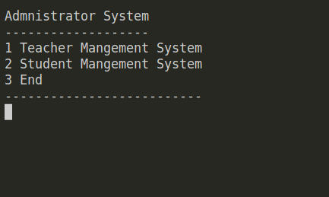

2 Now I have selected Teacher Mangement System

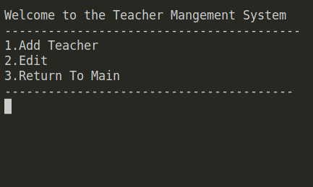

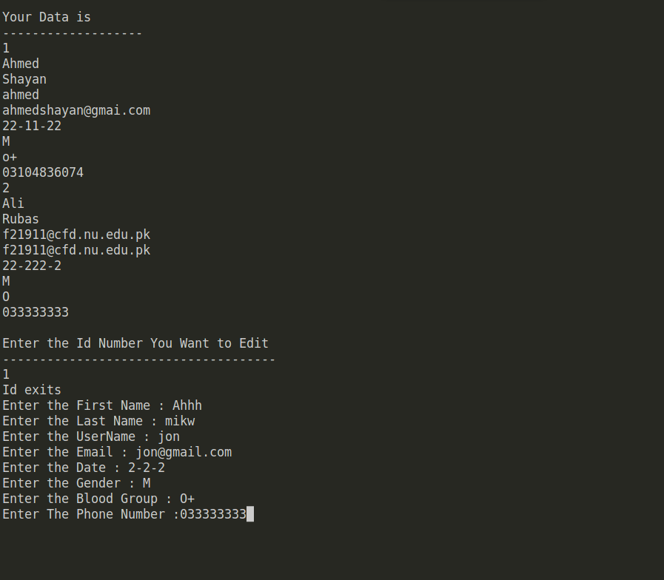

3 I have Asscessed Edit Data so it Allows me to Edit the Data

Now My Data is Changed So 1’st Data is Changed

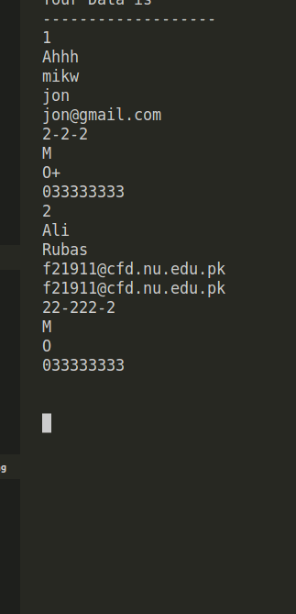

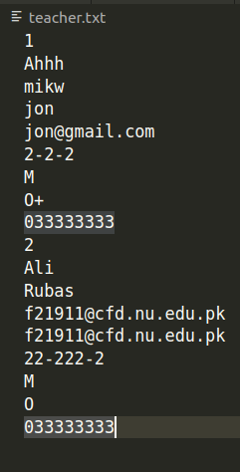

Now I again Go to The Add Teacher to Add Teacher Above Is MY Data Before Adding

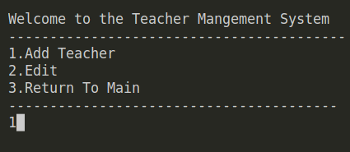

Data After Adding

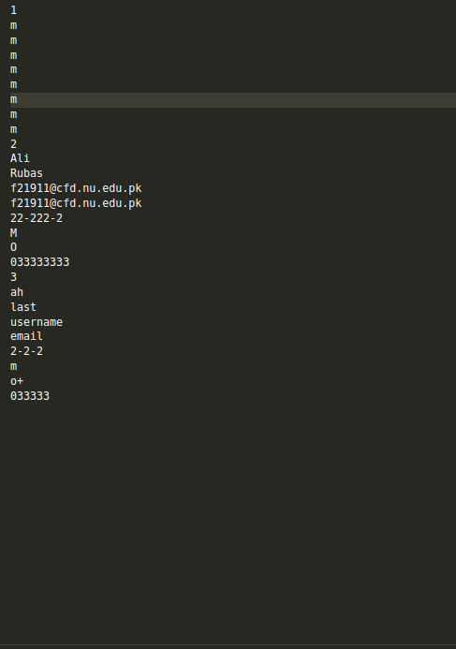

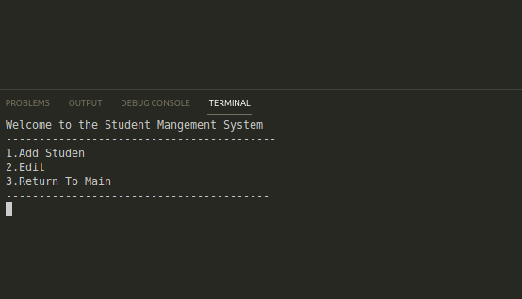
Now I go to the Student Management System

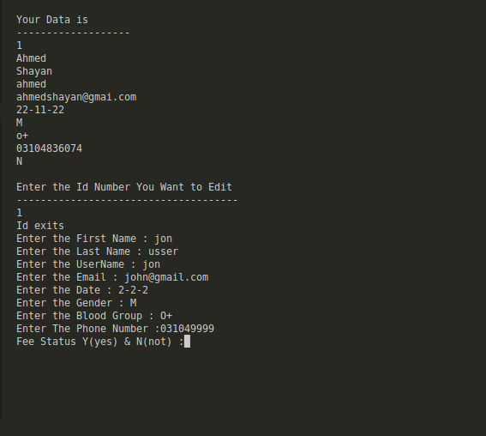
Data After Changing

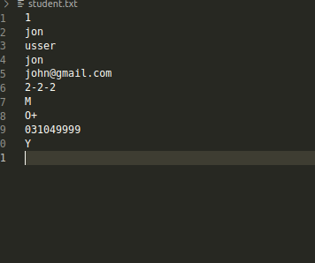

Data in File

Now I have Add the Data Data After Adding if Following
